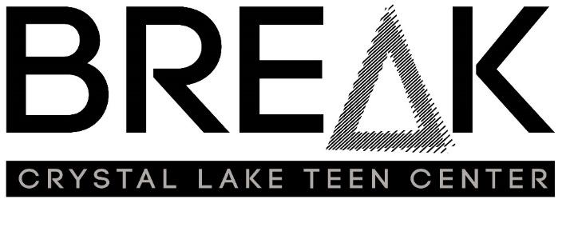
Rental Information
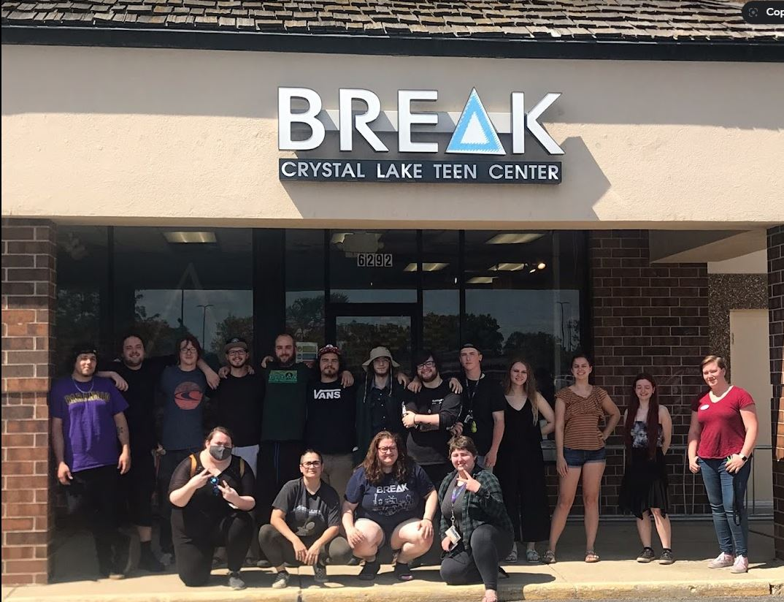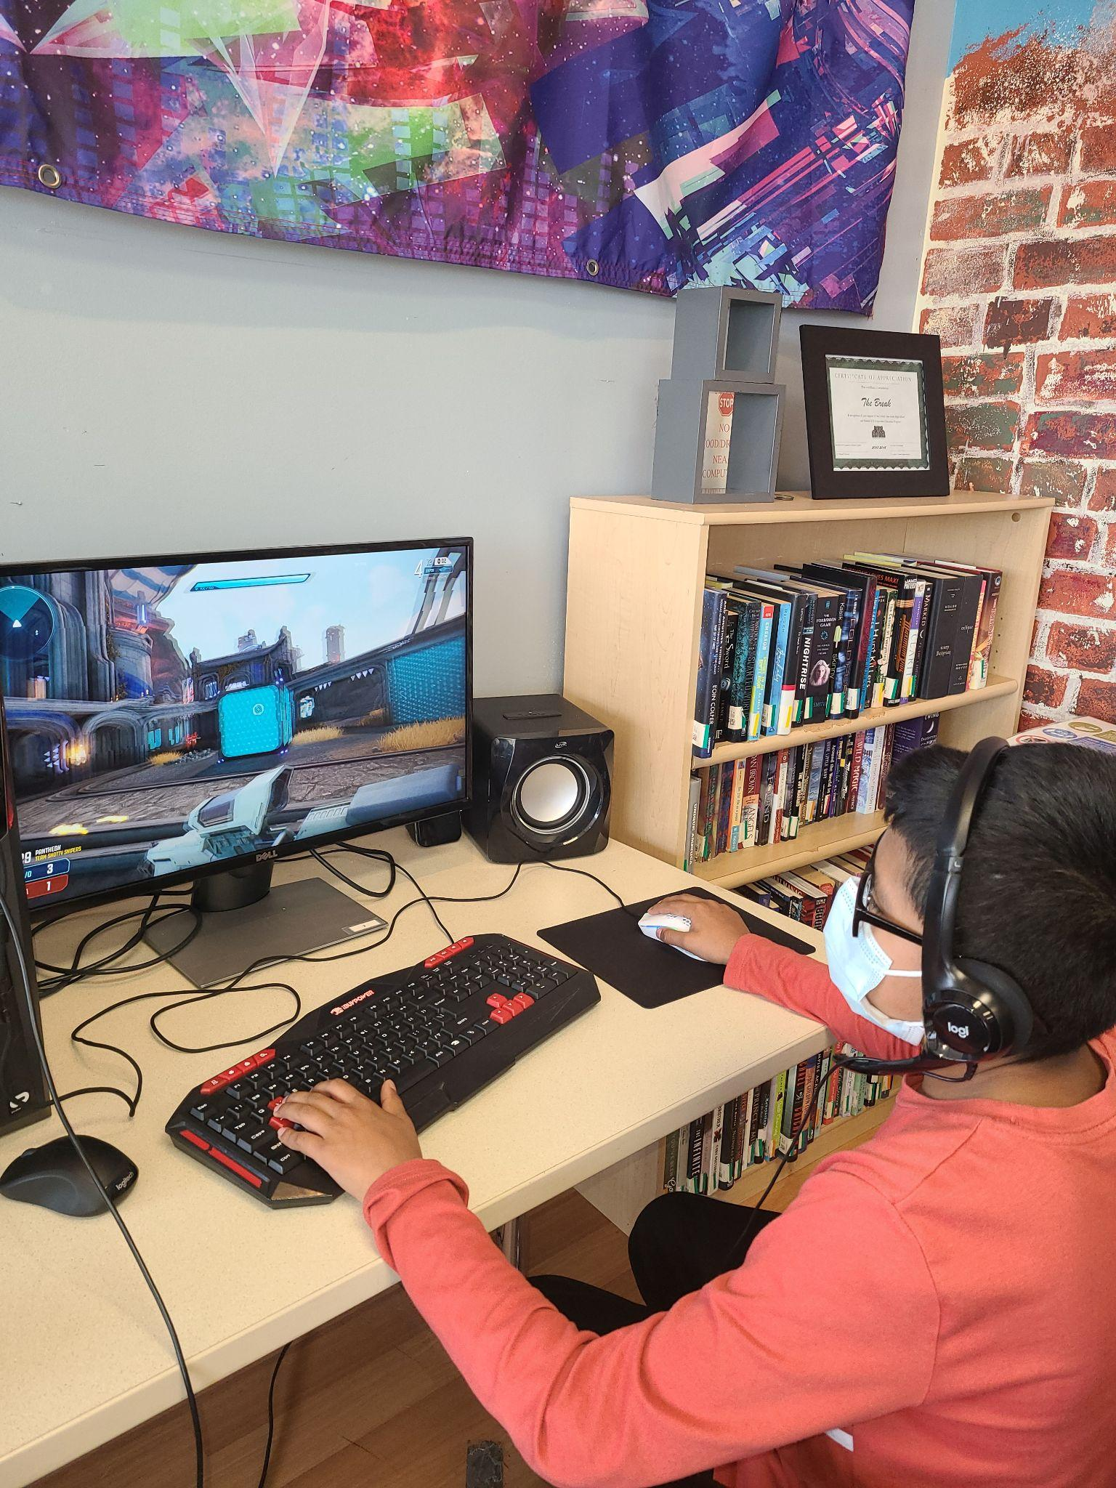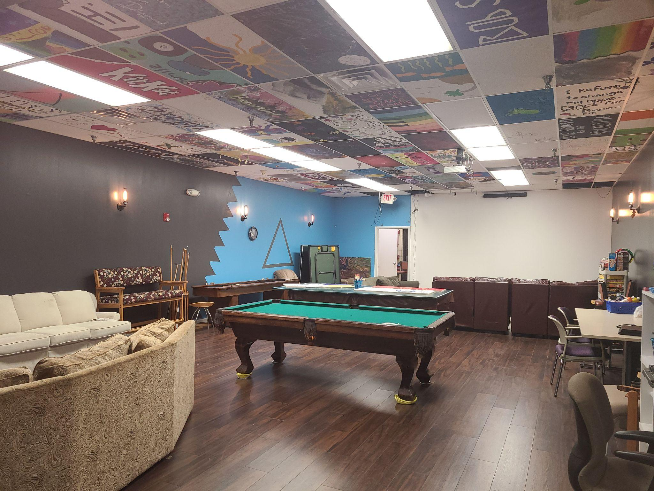
The Break is a teen center serving young people across McHenry County. We help the next generation of middle schoolers, high schoolers, and young people 18-26 find tools they need to grow through adolescence to thrive into adulthood.

We also rent out our teen center for youth groups, sports teams, birthday parties, musical groups and more. Our ‘living room’ concept and creative decor comes from our members' sense of ownership in the space and a homelike quality that makes both young people and adults comfortable and happy.

Come visit our convenient location at 6292 Northwest Highway, Crystal Lake, IL 60014 or check out our website gallery for more pictures of the center at www.clbreak.com.

Rental includes
  - Pool
  - Table tennis
  - Projector
  - Surround sound
  - Board games
  - Video Games
  - Gaming computers
  - Recording equipment
  - Microphones
  - Guitars
  - Drum set
  - Keyboard

For more information, please contact Ashley Burk at aburk@clbreak.com
.
The Break Rental Application
One week prior to the event, all renters must submit:
- $100 deposit
- Completed rental form
- For community organizations, nonprofits and businesses, a copy of current Certificate of Insurance showing general liability of at least $1,000,000 per occurrence, and naming the Crystal Lake Teen Center (dba The Break)Village of as an additional party insured. Contact staff if you have questions about insurance.
Break Renters agree to:
- Share the total number of people scheduled to attend and actual youth attendance (i.e 10 young people ages 11-18, 5 young adults ages 18-26)
- Set up and clean up time included in the rental time
- Move furniture back to its original location
- Take garbage out to back dumpster
- Clean up all countertops, bathrooms, and kitchen area
- Clean floors if there is excessive mess
The Break does not:
- Allow candles or anything with an open flame other than birthday cake candles
- Provide eating utensils, plates, cups, dishes, tablecloths or decoration supplies
- Store anything left behind
- Allow decorations to be hung with nails or thumbtacks
The use of controlled substances or alcohol is prohibited at the Break. Smoking, vaping , and gambling are not permitted in the building or in front of the building.
Refunds will not be issued for rentals ending earlier than stated on the reservation agreement or cancellations less than 48 hours prior to the event.
Extended rentals may be assessed additional staffing fees at the rate of $25.00 per hour per staff.
The Break retains the authority to determine unacceptable behavior of renters while on the premises and the right to cancel reservations or request an offender to leave. Renters found in violation of Break policies or any other criminal activity will be denied access.
Please note that Break sponsored events, drop in hours, and paying renters hold first priority status in facility scheduling.

Break Rental Categories
Type of Renter: | Description | Fee:
Category A: Young Adult Active Members | Young adult members ages 18 - 26 in good standing may rent the facility for 2-6 hours. Each participant must complete a membership application. | Each participant must be up to date on membership fees  $10/day or previously arranged number of monthly volunteer hours at the Break.
Category B: Active Adult Volunteer | Active adult volunteers (8+ volunteer hours/month) may rent the facility for 2-6 hours | $20/day or previously arranged number of monthly volunteer hours at the Break.  Volunteer to discuss type of use with staff to determine the need for staff on site.
Category C: Community organization or nonprofit | Youth-serving community group or non-profit including church youth groups, scouts, sports teams, choirs, music groups, and more. | $35/hour for up to three hours.  Group to discuss type of use to determine Break staffing needs.
Category D: Private party | Private youth party including birthdays, graduation, and other celebrations | $50/hour for up to four hours.  Group to discuss type of use to determine Break staffing needs. Additional fees may apply.
Category E: Business | Local or area business meeting or event | $65/hour up to three hours.  Group to discuss type of use to determine Break staffing needs. Additional fees may apply.

RENTAL CONTACT INFORMATION
Contact Name:
Organization:
Address: City/Zip
Phone: Cell Phone:
E-mail:

RENTAL INFORMATION
Day(s) & Date(s) of Event/Meeting:
Description of Event: # of people:
Start Time: End Time:

RENTER CATEGORIES
 | √ |  |  |  | Fee | # of people | # Hours | Fee Total
Category A: Active Member |  |  |  |  | TBD
Category B: Active Volunteer |  |  |  |  | TBD
Category C: Community group or nonprofit |  |  |  |  | $35 |  |  | $0
Category D: Private party |  |  |  |  | $50
Category E: Business |  |  |  |  | $65
Total Amount Due:

PAYMENT INFORMATION
Rental Fee Paid $: Date:
Check #: Cash:

Credit Card information
Card Number:
Expiration Date: 3 digit code:

Signature: Date:

Your signature indicates your acceptance of all regulations herein attached.

Renter Signature:_____________________________________ Date:_________________

Manager Signature: ____________________________________ Date:_________________

